DIGITAL/MOBILE WALLETS

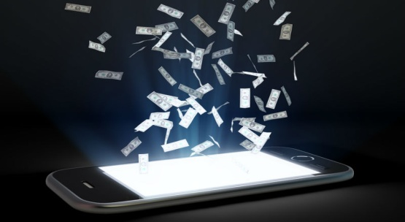
With growth in technology, things around us have changed a lot. Technology caters to man’s comfort and convenience. With the help of your smartphone, you can do everything. Be it ordering food or groceries, booking a cab or movie tickets, etc.
With the introduction of Mobile/Digital Wallet, it has become extremely convenient for a person to make cashless transactions. Due to this advantage provided by the Digital Wallets it plays a major role in the recent “Cashless India” initiative by the Government of India.

What is a mobile wallet ? 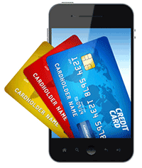
Mobile wallet is the digital form of a physical wallet in which we carry money. It is an online platform which allows a user to keep money in it, just like a bank account. A user needs to make an account with a mobile wallet provider. After which money is added to the ‘mobile wallet’ account using a debit, credit, online transaction from bank account or via cash.
The main difference between a mobile wallet and online transactions via bank account is that, unlike banks mobile wallet does not charge any amount of money on every transaction and saves the customer from the time spent in entering card details and pin number for each and every transaction.
It is easy and convenient as the user just needs to sign into the account and make the payment. Some of the mobile wallet providers are Paytm, Citrus, Oxigen, Freecharge, Mobikwik, Zaakpay, ItzCash etc.

Initiatives by RBI towards mobile wallet adoption.
RBI has been a pro-active thinker to help in supporting the use of the Mobile Wallets and has been very liberal in issuing licenses. Policies are decided and implemented by the The Reserve Bank of India (RBI). The RBI has been bringing in changes such as increasing the limit of how much money a user can save in the wallet, allowing wallet to wallet money transfers, and direct fund transfer to bank accounts.

How are customers benefiting from this?
Convenience and speed of doing the transaction are the main benefits. Mobile wallet users enjoy greater flexibility in making secure payments.
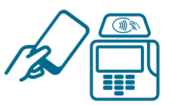 Make in-store purchases. Just hold your device to pay.

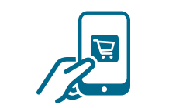 Make quick and secure purchases.

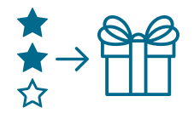 Receive offers. Many wallets and cards offer rewards and discounts.

How mobile wallets work?
- Download the mobile wallet app.
- Add your credit card or debit card information to the mobile wallet.
- When you check out at certain online stores, access the mobile wallet and choose your card. If you’re making an in-store purchase, just hold your mobile device at the terminal/scanner.

