ATM / OTP ISSUES
ATM Machine
A cash machine, also known as an automated teller machine or automatic teller machine, cashpoint, is an electronic telecommunications device that allows the customers to perform financial transactions, particularly cash withdrawal, without the need for a human cashier, clerk or bank teller.
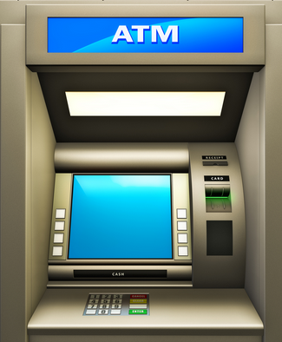

The modern ATMs, the customer is identified by inserting an ATM card with a chip that contains a unique card number and some data such as an expiration date, CVV (Card Value Verification) code and customer name. Customer identification and authentication is provided by the customer providing a personal identification number (PIN).
ATM Issues
In recent times there have been an increase of ATM frauds in the country and even across the globe. Managing the risk associated with ATM fraud as well as reducing its impact is an important issue. Some of the types of ATM Attacks/frauds are mentioned below.

Card Skimming
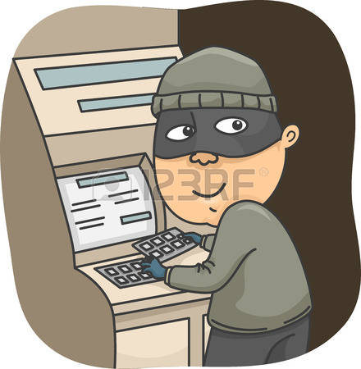
This remains the number one threat globally. Skimming refers to the stealing of the electronic card data thereby allowing the criminals to counterfeit/fake the card. Consumers experience a normal ATM transaction and are usually unable to notice a problem until their account is recovered and secured from the fraud.

Card Trapping

Trapping is the stealing of the physical card itself through a device fixed to the ATM.

Shoulder Surfing

This kind of fraud is where the criminal around you or try to understand your PIN number while you are entering it in the machine.
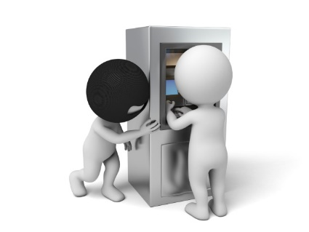

Physical Attacks
This category is related to any attempt to rob the ATM of the cash in the safe. Methods of physical attacks include solid and gas explosives, as well as removing the ATM from the site and then using other methods to gain access to the safe.

Logical Attacks
In this type of attack, external electronic devices, or malicious software in used in the crime. The tools are used to allow the criminal to take physical control of the ATM dispenser to withdraw money, which is often called "cash-out" or "jackpotting," as the machine starts spitting out bills like a casino gaming machine.
ATM safety tips

- Always protect your ATM card and keep it in a safe place, just like you would cash, credit cards or checks.
- Always pay close attention to the ATM and your surroundings.
- Do not allow people to look over your shoulder as you enter your PIN.
- Memorize your PIN.
- Never write it on the back of your card.
- Closely monitor your bank statements, as well as your balances, and immediately report any problems to your bank.

